# REAL TIME HAND GESTURE DETECTION

# FOR MATHEMATICAL CALCULATION

A PROJECT REPORT

***Submitted by***

**Sajal Korde (221B319)**

**Shruti Bhargava (221B374)**

**Snehil Sharma (221B387)**

**Under the guidance of: Prof. Sanjay Garg**



May - 2025

***Submitted in partial fulfillment for the award of the degree of***

**BACHELOR OF TECHNOLOGY**

**IN**

COMPUTER SCIENCE & ENGINEERING  
**Department of Computer Science & Engineering  
JAYPEE UNIVERSITY OF ENGINEERING & TECHNOLOGY  
AB ROAD, RAGHOGARH, DT. GUNA-473226 MP, INDIA**

# Declaration by the Students

We hereby declare that the work reported in the B. Tech. project entitled as “**REAL TIME HAND GESTURE DETECTION FOR MATHEMATICAL CALCULATION**”, in partial fulfillment for the award of degree of Bachelor of Technology submitted at **Jaypee University of Engineering and Technology, Guna**, as per best of our knowledge and belief there is no infringement of intellectual property right and copyright. In case of any violation, we will solely be responsible.

Sajal Korde (221B319)

Shruti Bhargava (221B374)

Snehil Sharma (221B387)

Department of Computer Science and Engineering

Jaypee University of Engineering and Technology  
Guna, M.P., India

Date:06/05/2025

 **JAYPEE UNIVERSITY OF ENGINEERING &TECHNOLOGY**

**Grade ‘A+’** Accredited with by NAAC & Approved U/S 2(f) of the UGC Act, 1956

A.B. Road, Raghogarh, Dist.: Guna (M.P.) India, Pin-473226

Phone: 07544 267051, 267310-14, Fax: 07544 267011

Website: www.juet.ac.in

# CERTIFICATE

This is to certify that the work titled “**REAL TIME HAND GESTURE DETECTION FOR MATHEMATICAL CALCULATION**” submitted by “**Sajal Korde (221B319), Shruti Bhargava (221B374), Snehil Sharma (221B387)**” in partial fulfillment for the award of degree of B.Tech of **Jaypee University of Engineering & Technology, Guna** has been carried out under my supervision. As per best of my knowledge and belief there is no infringement of intellectual property right and copyright. Also, this work has not been submitted partially or wholly to any other University or Institute for the award of this or any other degree or diploma. In case of any violation concern student will solely be responsible.

Signature of Supervisor

**Prof. Sanjay Garg**

Head of Department (CSE)

Date:06/05/2025

# ACKNOWLEDGEMENT

First and foremost, we would like to express our gratitude to Jaypee University of Engineering and Technology, our college, for giving us this chance to share our collective talents. We would also like to extend our sincere gratitude to Prof. Sanjay Garg, our project mentor and supervisor, who has supported us during all the challenges and issues we encountered enroute to finishing our project. We also want to express our gratitude to our mentor, who spent valuable time proofreading and fixing our mistakes in addition to offering us solutions and pointing us in the right direction. We also acknowledge the invaluable assistance provided by our parents and friends in helping us to complete this project on time. To cap it off, we extend our heartfelt thanks to the team members of “REAL TIME HAND GESTURE DETECTION FOR MATHEMATICAL CALCULATION.”

**Sajal Korde (221B319)**

**Shruti Bhargava (221B374)**

**Snehil Sharma (221B387)**

Date: 06/05/2025

**EXECUTIVE SUMMARY**

As technology advances, new methods for interacting with machines are emerging beyond traditional keyboards and touchscreens. Recognizing the challenges in expressing complex mathematical symbols quickly and efficiently, our project focuses on developing an AI-powered air-writing calculator that enables users to perform mathematical operations by writing in the air. By utilizing hand tracking and Convolutional Neural Networks (CNNs), we aim to create an intuitive tool that simplifies mathematical input.

The motivation for this project arises from the difficulty of typing or verbally describing complex mathematical expressions such as integration symbols, differentiation operations, and matrices. These symbols are often not easily accessible on standard keyboards, and explaining them in words can be time-consuming. Our system addresses this challenge by allowing users to directly write mathematical symbols in the air, providing a faster and more natural means of input. Currently, the system recognizes basic operations such as addition, subtraction, multiplication, division, factorial, and square root. However, it is designed to be scalable, with the potential for future expansions to more advanced operations.

To achieve this, we use hand tracking to monitor finger movements and create a virtual writing canvas. The captured gestures are processed through a CNN model trained to recognize mathematical symbols and numbers. Efficient hand landmark detection is implemented using MediaPipe, ensuring smooth gesture tracking and high accuracy. Our Streamlit-based interface integrates real-time camera feed, gesture visualization, expression building, and result display, offering a seamless user experience.

The project has significant potential applications in educational environments, remote learning, technical presentations, and assistive technologies. It also emphasizes the growing importance of natural and contactless user interfaces.

In summary, our AI-powered air-writing calculator provides an innovative, scalable solution to enhance mathematical input, making human-computer interaction more natural, efficient, and accessible.

##### List of Figures

|  |  |  |  |
| --- | --- | --- | --- |
| **S. No.** | **Figure No.** | **Figure Name** | **Page No.** |
| 1. |  |  |  |
| 2. |  |  |  |
| 3. |  |  |  |
| 4. |  |  |  |
| 5. |  |  |  |

# Table of Contents

REAL TIME HAND GESTURE DETECTION i

FOR MATHEMATICAL CALCULATION i

Declaration by the Students ii

CERTIFICATE iii

ACKNOWLEDGEMENT iv

Table of Contents vii

1.1 Problem Statement 1

1.2 Motivation for Work 1

1.3 Goal and Objectives 3

1.4 Project Overview 3

Chapter 2 5

2.1 Overview of Existing Research 5

2.2 Summary 6

Chapter 3 7

3.1 Hardware Requirements 7

3.2 Software Requirements 8

3.2.1 Operating Systems 8

3.2.2 Programming Language 8

3.2.3 Python Libraries 8

3.2.4 Model Requirements 10

3.2.5 Real Time Detection Requirements 10

3.2.6 Performance and Optimization Requirements 11

3.2.7 Jupyter Notebook 11

3.2.8 PyCharm 12

Chapter 4 13

4.1 Proposed System and Advantages 13

4.1.1 Proposed System 13

4.1.2 Advantages 14

4.2 Methodology 15

4.2.1 Data Collection 15

4.2.2 Data Preprocessing 15

4.2.3 Model Selection 16

4.3 System Design 18

4.2.3 System Architecture 18

4.3.2 Component Interaction 20

Chapter 5 21

5.1 Performance Metrics 21

5.1.1. Accuracy 21

5.1.2. Precision 21

5.1.3. Recall 21

5.1.4.F1-Score 22

5.1.5. Confusion Matrix 22

5.1.6. Real-Time Inference Time 22

5.1.7. False Positive Rate 22

5.2 Result Analysis 23

5.2.1 ROC Curve 23

5.2.2 Confusion Matrix 23

5.3 Screenshots 24

24

Conclusion 25

References 26

Contributors 27

##### Chapter 1

##### INTRODUCTION

## 1.1 Problem Statement

## 

Traditional input methods for complex mathematical expressions, such as keyboards or voice commands, are inefficient and cumbersome. Many mathematical symbols, like integration, differentiation, and matrices, are either difficult to access or require time-consuming searches. This creates barriers for students, professionals, and anyone working with advanced math, slowing down calculations and problem-solving.

Existing solutions, such as digital calculators and equation editors, still require users to navigate complex interfaces or input symbols manually, which can be tedious and error-prone. Additionally, these methods may not be accessible for individuals with disabilities or those who struggle with physical input devices.

There is a clear need for a more intuitive, efficient, and accessible way to input mathematical expressions. This project addresses that gap by using air-writing technology to recognize and process mathematical symbols in real-time, offering a faster and more natural alternative for mathematical input.

## 1.2 Motivation for Work

The motivation behind developing the AI-powered air-writing calculator arises from the need to improve the efficiency and accessibility of mathematical input. Traditional methods for entering complex mathematical symbols—whether through typing on a keyboard or using voice commands—are often inefficient, cumbersome, and time-consuming. This project is driven by the following core motivations:

* **Simplifying Mathematical Input**: Existing input methods for complex mathematical expressions are slow and prone to error. Many symbols and operations, such as integrals, derivatives, or matrices, are either hard to access or require tedious navigation through menus. Our aim is to create an intuitive, user-friendly system that allows individuals to input mathematical equations simply by writing in the air. This contactless method of inputting data makes mathematical problem-solving significantly faster, smoother, and more efficient, eliminating the need for manual searching or explaining of symbols.
* **Enhancing Productivity**: Students, professionals, researchers, and educators often waste valuable time searching for or explaining mathematical symbols, which can be frustrating and disruptive to their workflow. By enabling users to write directly in the air, our system facilitates an uninterrupted flow of work. This enhancement in productivity allows for more time spent on solving problems rather than managing inputs, ultimately increasing efficiency and streamlining the learning or work process.
* **Accessibility and Inclusivity**: Many traditional mathematical input systems are not designed with accessibility in mind, leaving individuals with physical disabilities at a disadvantage. Typing or using voice commands is not always feasible for everyone. Our project focuses on inclusivity, providing a natural, gesture-based input method that is contactless, easy to use, and accessible to people with diverse physical abilities. This ensures that more individuals, regardless of their physical limitations, can engage with and solve mathematical problems effectively.
* **Harnessing Technological Advancements**: In today’s world of rapid technological progress, we have an unparalleled opportunity to leverage cutting-edge tools such as artificial intelligence (AI), hand tracking, and Convolutional Neural Networks (CNNs) to revolutionize the way we interact with machines. Our project takes advantage of these advanced technologies to create a system that is both highly intuitive and scalable. By incorporating AI and hand tracking, we are developing a solution that provides real-time recognition of hand gestures, making it a versatile tool for a variety of users.
* **Usability and Practicality**: For any technological solution to be truly effective, it must seamlessly integrate into the user’s routine. Our air-writing calculator is designed to be both easy to use and unobtrusive. The system is intuitive, providing users with an enhanced experience without requiring additional steps or distractions. The goal is to provide an interface that feels natural and is practical for users in real-world settings, minimizing the learning curve while maximizing utility.
* **Expanding the Horizon**: While the current version of the system supports basic mathematical operations such as addition, subtraction, multiplication, division, factorials, and square roots, the true potential lies in its scalability. Our system is designed to grow with users’ evolving needs. Future updates will allow it to handle more advanced operations such as integration, differentiation, and matrix calculations, ensuring it remains a powerful and relevant tool for complex mathematical problem-solving in diverse fields.

## 1.3 Goal and Objectives

The primary goal of this project is to develop an AI-powered air-writing calculator that allows users to perform mathematical operations through hand gestures. The system will leverage **hand detection** and **Convolutional Neural Networks (CNNs)** to process and recognize gestures, enabling a seamless and intuitive method of input for mathematical expressions.

The main objectives of the project are:

* **Hand Detection**: Implement an efficient system for detecting hand movements and gestures in real time, creating a virtual canvas for mathematical input.
* **Numeral Extraction**: Develop the capability to extract numerals and mathematical symbols from the detected hand gestures accurately.
* **Expression Calculation**: Implement functionality to calculate the respective mathematical expressions based on the recognized gestures and symbols.
* **Result Display**: Display the calculated result to the user in real-time, offering immediate feedback on the entered expression.

## 1.4 Project Overview

The AI-powered air-writing calculator aims to revolutionize how users perform mathematical operations by utilizing hand gestures. This project addresses the challenge of efficiently inputting complex mathematical symbols, which are often difficult to type or explain through conventional methods.

The system uses **hand detection technology** to track the user’s hand movements, extracting numerals and symbols from air-written gestures. Convolutional Neural Networks (CNNs) are employed to accurately recognize these gestures and calculate the corresponding mathematical expressions. The results are then displayed in real-time, offering an intuitive and efficient way to perform calculations.

Currently, the system supports basic mathematical operations such as addition, subtraction, multiplication, division, factorials, and square roots. However, the design is scalable, allowing future expansion to include more advanced operations, such as integration and differentiation.

The project aims to enhance productivity, accessibility, and user experience by providing a contactless solution for mathematical input. By integrating advanced technologies like hand tracking and CNNs, the air-writing calculator simplifies the process of mathematical problem-solving, making it faster, more efficient, and accessible for users across various fields, including education and professional environments.

# 

# Chapter 2

**LITERATURE SURVEY**

## 2.1 Overview of Existing Research

This section introduces the background and research context for real-time hand gesture recognition systems aimed at performing mathematical calculations through air-writing. The ability to recognize and interpret gestures for numeric and symbolic input has significant implications in making human-computer interaction more natural, contactless, and accessible, especially in fields like education, augmented reality, and assistive technology.

Several research efforts have explored hand gesture recognition, air-writing, and symbol interpretation, employing diverse approaches based on computer vision and machine learning. Early studies focused on static gesture recognition using traditional image processing techniques. Recent advancements have incorporated deep learning methods, such as convolutional neural networks (CNNs) and recurrent neural networks (RNNs), to handle dynamic gestures and sequential input more effectively. Techniques like background subtraction, hand key-point detection, and trajectory tracking have been used to capture hand movement in real-time, while recognition models are trained to classify digits, operators, and even complex mathematical expressions.

Research challenges include achieving high accuracy in varied lighting conditions, handling occlusions, differentiating between similar gestures, and ensuring low-latency performance for real-time applications. Some studies emphasize the integration of spatial-temporal modeling, attention mechanisms, and multi-modal data (e.g., RGB-D cameras) to enhance recognition reliability and robustness.

Overall, the field of real-time gesture recognition for mathematical calculations remains a promising area of study, with ongoing innovations aimed at improving system efficiency, user adaptability, and seamless integration into interactive environments.

**Handwriting Recognition in Air using a Smartphone IMU (14 March 2023, Hao Li et al.)**

The system captures 3D motion trajectories using a smartphone’s inertial sensors to recognize air-written text. A transformer-based model segments and interprets strokes, achieving robust handwriting recognition without visual input devices.

**Air-Writing Character Recognition Using OpenPose and Deep Neural Network (27 December 2024, Ki-Seo Chungetal.)**

The method uses OpenPose to track fingertip motion and recognize air-written characters with deep neural networks. It improves air-writing accuracy under free-form motion conditions, using sequential hand joint data as input features.

**Write in Air: Handwriting Recognition Using Inertial Measurement Unit (7 September 2018, Saket Anand et al.)**

This study introduces a smartphone-based system that uses inertial sensors to recognize English letters written in the air. A recurrent neural network processes the accelerometer and gyroscope data, achieving high accuracy for isolated character recognition.

**Finger Air Writing Recognition System with Wearable Inertial Sensor and Hidden Markov Model (15 October 2019, Daisuke Asano et al.)** The system employs a wearable ring sensor to capture hand motions for air-writing, using a Hidden Markov Model to classify character sequences. It focuses on reducing noise and drift errors for stable real-time performance.

**Real-time Air Writing Recognition for Digits using CNN-RNN Model (2024, A. Pradeep et al.)** The approach combines convolutional and recurrent neural networks to recognize air-written digits from continuous hand motion. By using trajectory images and sequential modeling, it achieves high real-time accuracy with low latency.

## 2.2 Summary

In these studies, various systems for air-writing recognition were developed using different sensors and models. One approach uses a smartphone’s IMU (accelerometer and gyroscope) to capture 3D motion trajectories, employing a Transformer-based model to recognize handwritten characters in real time. Another system tracks fingertip motion using OpenPose and classifies characters with a deep neural network. Some studies use inertial sensors or wearable devices, combined with models like RNN or HMM, to recognize motion-based handwriting. These systems aim to provide natural, contactless methods for handwriting input, offering potential applications in mobile devices, smart classrooms, and virtual environments.

# Chapter 3

**SYSTEM REQUIREMENTS**

## 3.1 Hardware Requirements

**Minimum Specifications**

1.Processor: Intel Core i3 (2.4 GHz or faster)

Reason: The model inference and OpenCV processing require moderate computational

power for real-time operations.

2.RAM: 8 GB

Reason: To be able to handle image processing, model inference, and running multiple software simultaneously.

3.Storage: At least 10 GB free space

Reason: To store the dataset, trained model, and necessary dependencies.

4.Camera: Standard USB or built-in webcam with 720p resolution

Reason: To record the live video feed of the driver for analysis.

5.Display: Monitor of at least a 1024x768 resolution

Reason: To show the live feed and analysis during testing.

**Suggested Specifications**

1.CPU: Intel Core i5 or AMD Ryzen 5 (2.8 GHz above)

Reason: It will offer faster processing for the high-accuracy real-time detection.

2.RAM: 16 GB

Reason: This is optimum and shall ensure high performance during training, inference, and multi-tasking.

3.GPU: At least NVIDIA GTX 1050 or higher, CUDA-enabled

Reason: It accelerates model training and speeds up image processing tasks.

4.Storage:50 GB SSD or HDD (SSD preferable because the read/write speeds are faster)

Reason: To have the space for dataset storage, preprocessed file storage, and extra software

5.Camera: Full HD (1080p) webcam

Reason: Higher accuracy face and eye detection.

## 3.2 Software Requirements

### 3.2.1 Operating Systems

* Windows: Windows 10 or 11 (64-bit)
* Linux: Ubuntu 20.04 or higher
* macOS: Monterey or Ventura

### 3.2.2 Programming Language

(Python 3.6 or above)

Python is an interpreted, high-level, general-purpose programming language. Python is simple and easy to read syntax emphasizes readability and therefore reduces system maintenance costs. Python supports modules and packages, which promote system layout and code reuse. It saves space but it takes slightly higher time when its code is compiled. Indentation needs to be taken care of while coding. Python does the following:

1. Python can be used on a server to create web applications.
2. It can connect to database systems. It can also read and modify files.
3. It can be used to handle big data and perform complex mathematics.
4. It can be used for production-ready software development.

Python has many inbuilt library functions that can be used easily for working with machine learning algorithms. All the necessary python libraries must be pre- installed using “pip” command.

### 3.2.3 Python Libraries

* TensorFlow 2.x

TensorFlow 2.x is an open-source deep learning framework developed by Google, used extensively for building, training, and deploying machine learning models. In this project, TensorFlow played a crucial role in developing the Convolutional Neural Network (CNN) model that can classify handwritten digits and mathematical operators drawn through air gestures. It offers seamless GPU acceleration, which greatly improves training and inference speed, making it ideal for real-time applications like air-writing recognition.

Key Features:

• Provides GPU acceleration for faster model training and inference.

• Integrated support for CNNs and other deep learning architectures.

• Offers high-level APIs along with flexibility for complex customization.

* Keras

Keras, now part of TensorFlow 2.x, is a high-level deep learning API that simplifies the process of building and training machine learning models. It offers an intuitive and modular approach for defining layers, compiling models, and handling training loops. In this project, Keras was used to easily construct the CNN architecture for recognizing drawn characters, leading to faster prototyping and deployment.

Key Features:

• Simple and user-friendly API for building deep learning models.

• Supports rapid experimentation with different neural network architectures.

• Built-in callbacks like EarlyStopping to optimize training processes.

* OpenCV (cv2)

OpenCV (Open Source Computer Vision Library) is a highly efficient computer vision library that provides tools for real-time image processing. In this project, OpenCV was used to capture video from the webcam, preprocess frames, draw on a virtual canvas, and apply transformations such as grayscale conversion and thresholding to prepare inputs for model prediction.

Key Features:

• Real-time video capture and processing from webcams.

• Provides powerful image preprocessing functions like thresholding, contour detection, and resizing.

• Essential for creating the virtual drawing environment.

* CVZone

CVZone is a computer vision library that simplifies tasks like hand tracking, face detection, and object detection by building on top of OpenCV and MediaPipe. It provided an easy-to-use interface for hand detection and finger counting, enabling gesture-based controls to manage drawing, predicting, clearing the canvas, and evaluating expressions.

Key Features:

• High-level hand tracking functionality with minimal setup.

• Provides intuitive finger status (up/down) detection.

• Simplifies gesture recognition for real-time interaction.

* NumPy

NumPy is a fundamental Python library for numerical computations. It was essential for handling image data arrays, performing normalization, reshaping inputs for the CNN model, and processing prediction outputs. Its optimized operations made dataset manipulation and preprocessing highly efficient.

Key Features:

• Efficient multi-dimensional array and matrix operations.

• Essential for preprocessing and reshaping image data.

• Improves performance when handling large datasets.

* scikit-learn

Scikit-learn (sklearn) is a versatile machine learning library in Python that was used primarily for splitting the dataset into training and testing sets. It provided a simple and reliable way to prepare the data for training the CNN model.

Key Features:

• Easy-to-use data splitting with train_test_split.

• Supports evaluation metrics and preprocessing utilities.

• Lightweight and integrates seamlessly with TensorFlow pipelines.

* math

The built-in math module in Python was vital for evaluating mathematical expressions involving constants and functions such as π, square roots, and factorials. It ensured that the recognized expressions could be calculated safely and accurately.

Key Features:

• Provides essential mathematical functions and constants.

• Enables secure evaluation of dynamic mathematical expressions.

• Crucial for interpreting advanced operations like square roots and factorials.

* Matplotlib (optional during development)

Matplotlib was used during the model development phase for visualizing training and validation accuracy and loss curves. This helped in monitoring the model's learning progress and fine-tuning training parameters.

Key Features:

• Enables visualization of training metrics over epochs.

• Helps detect overfitting or underfitting trends visually.

• Useful for diagnostic analysis during model development.

### 3.2.4 Model Requirements

Trained CNN Model:

Type: CNN; used for classification.

Model File: Loaded model that makes inferences on the real-time detection. It is given in the form of a pre-trained model file: fatigue_model_cnn.h5.

Model Input Size: The size of the input image during inference is 224x224. For most pre-trained models, 224 is the commonly used number.

Model Output: The model classifies the driver state into two classes: Active (0) and Sleepy (1).

Training Data: The processed data set of images belonging to two classes that is, active and sleepy was prepared and augmented as per the requirement of the project.

### 3.2.5 Real Time Detection Requirements

1. Video Capture and Face Detection:

* The video feed from the webcam is captured using OpenCV. The webcam resolution must be at least 720p for proper facial feature detection.
* Haar Cascade Classifiers are used in order to detect faces and eyes from the video frames.

1. Frame Processing:

* Each frame is preprocessed by converting it to grayscale, detecting the face and eyes, and then resizing the eye region to 224x224 pixels before feeding it into the CNN model.
* Image normalization (scaling pixel values between 0 and 1) is applied to match the model's training conditions.

1. Decision Layer and Alarm System:

* This system keeps track of a sleepy count, which counts the number of successive frames in which the driver is classified as sleepy.
* An alarm is raised whenever the sleepy count goes beyond the threshold, set to 5 in the code, with a beep sound produced by winsound library. The alarm is reset when the driver is classified as "Active."

1. User Interface:

* A Real-time display window for the webcam feed is presented along with status text indicating if the driver is "Active" or "Sleepy."
* Finally, the frame is displayed by using OpenCV's imshow function, where a rectangle is drawn around the detected face for visual purposes:.

### 3.2.6 Performance and Optimization Requirements

**Latency**: The design should have low latency to make real-time predictions while recording a video. It is critical to alert the driver in time.

**Accuracy:** The model will need to result in high accuracy rate for determination of the driver state to be either active or sleeping, classed through the trained dataset. The false alarms must be minimized.

**Scalability**: The system should be able to adapt to different lighting conditions and varied drivers with minimal additional configuration or training data.

### 3.2.7 Jupyter Notebook

Jupyter Notebook is an interactive web application that allows you to create and share documents that contain live code, visualizations, and narrative text. It’s widely used in data science, machine learning, and academic research because it provides a flexible environment for experimentation and documentation. With Jupyter, you can write code in a variety of programming languages, visualize data, and include explanatory text, all in one place.

### 3.2.8 PyCharm

For Python programming, Jupyter Notebook is a popular choice, but if you prefer a more traditional development environment, PyCharm is an excellent option. PyCharm is a well-liked integrated development environment (IDE) that offers sophisticated code analysis, debugging, and project navigation tools. It supports databases, web development frameworks, and popular version control systems. With its intuitive interface and intelligent coding assistance, PyCharm enhances the efficiency of Python development. Whether you choose Jupyter Notebook for its interactivity or PyCharm for its robust features, both tools can effectively support your programming needs.

# Chapter 4

**DESIGN AND IMPLEMENTATION**

## 4.1 Proposed System and Advantages

### 4.1.1 Proposed System

The proposed system integrates a live detection tool for driver drowsiness based on deep learning, utilizing a Convolutional Neural Network (CNN) model in combination with computer vision techniques such as OpenCV and Haar Cascade Classifiers. The system is designed to classify the driver's eye state into "Active" or "Sleepy" and alert them in case of prolonged drowsiness. The key components of the system are:

1. Web Cam Integration to Monitor Live: This step involves integrating a webcam to capture live video frames of the driver's face. Each frame is analyzed in real-time to detect facial features.
2. 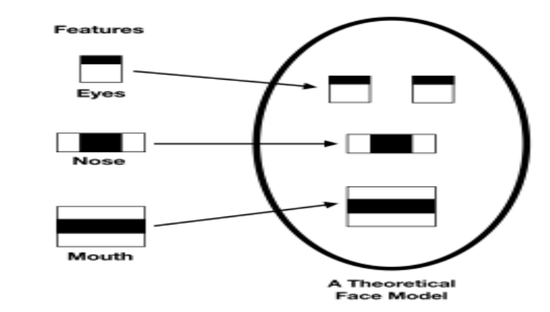Face Detection and Eye Detection using Haar Cascade Classifiers: OpenCV's Haar Cascade Classifiers are used to detect faces and eyes in each frame of video feed. Once we identify a face, we zoom in on the eye regions to ensure we capture the most critical details.

**Fig.1** Haar Cascade approach

1. CNN Model for Eye State Classification: The CNN model is used to classify eye regions into "Active" or "Sleepy." The reason behind choosing the CNN is for the ability to extract proper spatial features, particularly suited for real-time applications with robust and accurate prediction.
2. Alarm System Based on Sleepy Frame Threshold: If the system or the algorithm detects more than a given number of consecutive "Closed" eye frames, it activates the alarm. The mechanism, therefore, helps reduce false alarms resulting from minimal blinking and ensures that alerts are produced only when sleepiness is detected. In case the system detects drowsiness, it triggers an alert sound to wake the driver. When the driver's eyes recover into an "Open" state, the alarm automatically stops and the system returns to an "Active" status.
3. User-Friendly Implementation: We’ve built the system using Python, which makes it not only modular but also easy to tweak and expand as needed. This means we can easily add new features, like detecting yawning or tracking fatigue levels, without compromising the smooth operation of the system. Our goal is to create a seamless and non-intrusive driver drowsiness monitoring system that provides timely alerts, helping to keep drivers safe and prevent accidents on the road.

### 4.1.2 Advantages

The proposed system has a number of advantages over other existing techniques as follows:

1. Non-Intrusive and Non-Discomfort: Unlike methods that require physical sensors, our system uses just a camera to keep an eye on the driver’s attention. This means no uncomfortable devices are needed, making the driving experience much more pleasant.
2. Real-Time Detection and Response: Our CNN model works quickly, capturing and processing images in real time. This allows for immediate feedback, which can be crucial in preventing accidents caused by drowsiness.
3. Efficient and Optimized Performance: It uses the CNN architecture, which ensures robust feature extraction and accurate predictions. This model has good computational efficiency and can be easily deployed on standard hardware without much latency.
4. Enhanced Eye State Monitoring: The system focuses on monitoring whether the driver’s eyes are open or closed, providing a direct way to identify signs of drowsiness.
5. Adaptability to Real-World Conditions: Our system is designed to handle a variety of real-world situations utilizing OpenCV’s image processing capabilities.
6. Scalability for Future Development: The modular design of the system means it can easily be upgraded. This thoughtful approach, combined with the advanced capabilities of CNN, ensures that the system remains effective, user-friendly, and ready for real-world use.

## 4.2 Methodology

### 4.2.1 Data Collection

In our project, we started by gathering raw data from Kaggle, which offered a collection of images featuring open and closed eyes. This dataset included 726 images for each category, giving us a total of 1,452 images. While this was a good foundation, we quickly realized it wasn’t enough to effectively detect driver drowsiness. To address this limitation, we decided to enhance the dataset through a process called data augmentation.

To expand our collection, we employed several techniques to modify the original images. We rotated, shifted, and flipped them, creating five new versions of each image. This approach allowed us to significantly increase our dataset size to 7,260 images. By introducing this variety, we aimed to help our model learn to recognize eye states in different conditions and angles, making it more adaptable to real-world driving scenarios.

Once we had augmented the images, we resized them to ensure they were suitable for training our convolutional neural network (CNN). Resizing is important because it helps maintain image quality while fitting the model's input requirements. Additionally, we created an annotation file to label the images accurately, distinguishing between open and closed eyes. This labeling is crucial for supervised learning, as it provides the model with the information it needs to learn and make accurate predictions about driver drowsiness. Through these efforts, we aimed to build a comprehensive dataset that would enhance the effectiveness of our drowsiness detection system.

### 4.2.2 Data Preprocessing

Since the dataset obtained from Kaggle was not so big, preprocessing and augmentation were inevitable in order to rise the training performance and extend generalization for the model. The preprocessing process includes:

1. Image Resizing: The dimension of each image of the dataset has been resized into 224x224 pixels so that the model could work properly.
2. Data Augmentation: In order to expand the dataset and introduce variability, transformations have been applied:
   * Rotation: Images were randomly rotated between -30 and +30 degrees to simulate head movements.
   * Translation (Shifting): Horizontal and vertical shifts were applied to reflect slight positional changes.
   * Flipping: Horizontal flips were presented, introducing mirrored variations of each image-to help the model recognize features symmetrically.
   * Scaling and Cropping: We scaled zoom levels within small ranges so that minor scaling differences are induced in images.
3. Normalization: The pixel values for the image had to be normalized within the range 0-1, which again used the model learning features on features without variable lighting conditions or intensity of the image.

One preprocessing strategy was important in expanding the size and diversity of our data set, which would ensure that our model could efficiently train on limited original data while improving robustness in real-world scenarios.

### 4.2.3 Model Selection

Choosing the right model for detecting driver drowsiness is one of the most important decisions we made for our project. After exploring various options, we decided to go with a Convolutional Neural Network (CNN). This choice was influenced by the unique strengths of CNNs, especially when it comes to recognizing and classifying images—an essential aspect of identifying drowsiness.

Why CNN for Drowsiness Detection?

Particular Suitability to Vision Data:

CNNs are particularly well-suited for working with images. They excel at learning the spatial relationships in visual data, which makes them great at detecting whether a driver’s eyes are open or closed. This ability to automatically learn from the images means that our system can effectively pick up on subtle signs of drowsiness, helping to keep drivers safe on the road.

Automatic Feature Extraction

One of the standout features of CNNs is their capability to extract important characteristics from images without needing manual intervention. Unlike traditional methods that require us to specify what features to look for, CNNs can learn to recognize edges, shapes, and textures on their own. This is particularly useful for our project, as it allows the model to adapt to different eye patterns associated with drowsiness without extensive preprocessing.

High Accuracy and Performance:

CNNs have a proven track record of delivering high accuracy in image classification tasks. They are designed to handle variations in lighting and facial orientation, which are common in real-world situations. This robustness is crucial for our drowsiness detection system, as it needs to perform reliably no matter the conditions or the individual driver.

Scalability and Adaptability:

Another reason we chose CNNs is their scalability and adaptability. These models can easily be adjusted or expanded for specific applications, allowing us to improve performance as new challenges arise. Their modular design means we can integrate new techniques or layers into the model, ensuring that our system can evolve alongside advancements in technology.

|  |  |  |
| --- | --- | --- |
| *Model: “sequential_3”* |  |  |
| ***Layer (type)*** | ***Output shape*** | ***Param#*** |
| *Conv2D* | (None,222,222,32) | 896 |
| *BatchNormalization* | (None,222,222,32) | 128 |
| *MaxPooling2D* | (None,111,111,32) | 0 |
| *Dropout* | (None,111,111,32) | 0 |
| *Conv2D* | (None,109,109,64) | 18496 |
| *BatchNormalization* | (None,109,109,64) | 256 |
| *MaxPooling2D* | (None,54,54,64) | 0 |
| *Dropout* | (None,54,54,64) | 0 |
| *Conv2D* | (None,52,52,128) | 73856 |
| *BatchNormalization* | (None,52,52,128) | 512 |
| *MaxPooling2D* | (None,26,26,128) | 0 |
| *Dropout* | (None,26,26,128) | 0 |
| *Conv2D* | (None,24,24,256) | 295168 |
| *BatchNormalization* | (None,24,24,256) | 1024 |
| *MaxPooling2D* | (None,12,12,256) | 0 |
| *Dropout* | (None,12,12,256) | 0 |
| *Flatten* | (None,36864) | 0 |
| *Dense* | (None,128) | 4718720 |
| *Dropout* | (None,128) | 0 |
| *Dense*  **Total params**: 5,109,187  **Trainable params**: 5,108,225  **Non-trainable params**: 960  **Optimizer params**: 2 | (None,1) | 129 |

**Fig.2** CNN Architecture

## 4.3 System Design

### 4.2.3 System Architecture

The design of the architecture for the system of driver drowsiness detection is always real-time; therefore, it moves from the capture of video frames to the generation of alerts. The system consists of the following interconnected layers:

1. Data Input (Camera Feed)

* Purpose: Capture live video of the driver's face in real time.
* 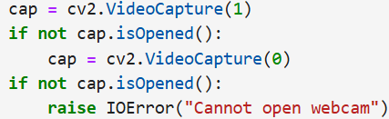Implementation: Initialize a webcam using OpenCV and attempt to open an external or built-in camera. Video Frames are captured continuously then are processed individually. If the webcam cannot open, error is raised.

1. Preprocessing Layer

* Motive: To prepare each video frame for further feature extraction and classification.
* Implementation: Face Detection - Haar Cascade Classifier is used for detecting the face of the driver within a frame. It makes sure that all the processing around the area of interest would be done. Eye Detection - Within the identified face, Haar Cascade Classifier identifies the areas for eyes. The regions are cropped and processed for classification.
* Image Resizing and Normalization: Crop the eye region to a size that will fit the CNN model's input size, 224 x 224. Normalize pixel values to be in the range of 0-1 through dividing by 255.0, thus having the same input go into the model.

1. Feature Extraction and Model Inference Layer

* Objective: Predict the state of the driver as Active or Sleepy through a CNN-based deep learning model.
* Loads: A pre-trained CNN model named fatigue_model_cnn.h5 is to be loaded using TensorFlow. The processed eye region is passed to the model for inference .The CNN model has outputs in the form of probabilities of two classes: Class 0 ‘Active’ and Class 1 ‘Sleepy’.
* 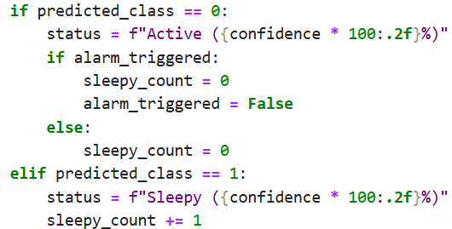The state with the maximum-probability prediction is selected and its respective confidence score is logged.

1. Decision Layer

* Goal: Predict across frames successively in order to avoid false alarms and determine at which frames to raise alerts.
* Sleepy Counter Mechanism: It keeps track of the count of successive frames classified as Sleepy. The threshold to ring an alarm is set to 5 consecutive Sleepy frames.
* Reset Mechanism: A frame identified as Active, the counter and all alarms triggered are reset to zero.
* Threshold-Based Alarm: Counter exceeding the threshold value, an audio alarm is invoked with winsound.

1. Alarm System

* Goal: Sound an alarm as soon as and as long as the system establishes that the driver is persistently sleepy.
* 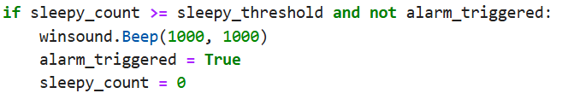Implementation: Audio beep is played using winsound. Beep whenever drowsiness is detected for the threshold number of consecutive frames. The system prevents unnecessary alerts by resetting the counter and deactivating the alarm after it has been triggered.

1. Real-Time Feedback (UI Layer)

* Function: Update in real time, the state of the driver across the video feed
* Implementation: The state of the driver as detected (Active or Sleepy) along with a confidence score overlay on the video feed using OpenCV. It also superimposes bounding boxes around detected faces to visually highlight the region of interest.

The processed frames are displayed in a window titled "Sleepiness Detection Window."

This layered architecture provides a sound and efficient drowsiness detection system that balances computational efficiency with real-time responsiveness to safeguard drivers.

### 4.3.2 Component Interaction

The interaction between components in the driver drowsiness detection system follows a structured flow to ensure efficient, real-time detection and alerting:

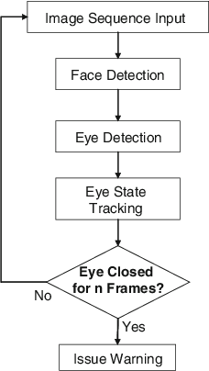

**Fig.3** Flowchart Implementation

# Chapter 5

**RESULT AND DISCUSSION**

## 5.1 Performance Metrics

For your system, the performance metrics focus on evaluating how well the model identifies the driver’s state (active or sleepy). Here are the key metrics for your project:

### 5.1.1. Accuracy

* **Description**: This metric measures the overall correctness of the model in classifying the driver’s state (active, sleepy, or yawning).
* **Formula**: Accuracy= $\frac{True Positives+True Negatives}{\begin{aligned}Total Predictions\end{aligned}}$
* **Relevance**: It shows how often the model makes the correct prediction, which is critical for ensuring the system performs reliably during real-time detection.

### **5.1.2.** **Precision**

* **Description**: Precision measures the accuracy of positive predictions (how many instances predicted as "Sleepy" are actually "Sleepy").
* **Formula**: Precision= $\frac{True Positives}{True Positives+False Positives}$

* **Relevance**: For drowsiness detection, high precision is important to avoid false positives (e.g., mistakenly detecting a driver as "Sleepy" when they are not).

### **5.1.3. Recall**

* **Description**: Recall measures the ability of the model to correctly identify all positive instances (how many "Sleepy" drivers are actually classified as "Sleepy").
* **Formula**: Recall= $\frac{True Positives}{True Positives+False Positives}$

* **Relevance**: High recall ensures that the model does not miss out on detecting a "Sleepy" driver, which is crucial for safety.

### 5.1.4.F1-Score

* **Description**: The F1-score is the harmonic mean of precision and recall, providing a balance between the two.
* **Formula**: F1-Score= $2 ×\frac{Precision ×Recall}{Precision+Recall}$

* **Relevance**: The F1-score is particularly important in this project as it balances the need to avoid false positives and false negatives, ensuring that both accurate detection and safety are maintained.

### 5.1.5. Confusion Matrix

* **Description**: A confusion matrix provides a breakdown of the model’s predictions against the actual labels, showing the true positives, true negatives, false positives, and false negatives.
* **Relevance**: The confusion matrix helps to visually identify where the model is making errors and provides insight into which states (active, sleepy, yawn) are being misclassified.

### 5.1.6. Real-Time Inference Time

* **Description**: Measures how long the model takes to process each frame of the camera feed and make predictions.
* **Relevance**: Since the system needs to detect drowsiness in real time, a fast inference time is crucial to ensure timely alerts.

### 5.1.7. False Positive Rate

* **Description**: The rate at which the model incorrectly classifies a non-drowsy driver as "Sleepy".
* **Formula**: FPR = $\frac{False Positives}{False Positives+True Negatives}$

* **Relevance**: A low false positive rate ensures that the model doesn't unnecessarily alert the driver, which could lead to distractions or inconvenience.

## 5.2 Result Analysis

### 5.2.1 ROC Curve

The training ROC curve displays the model’s ability to

distinguish between the two classes based on its predictions on the test data. From the Figure it is observed that, an AUC of 0.95 indicates that the model performs exceptionally well on the test set, as it achieves a high true positive rate while maintaining a low false positive rate across various classification thresholds. It is also observed that, a high AUC on the test data suggests that the model has effectively generalized and can reliably separate positive and negative examples in unseen data.

**Fig.4** ROC Curve

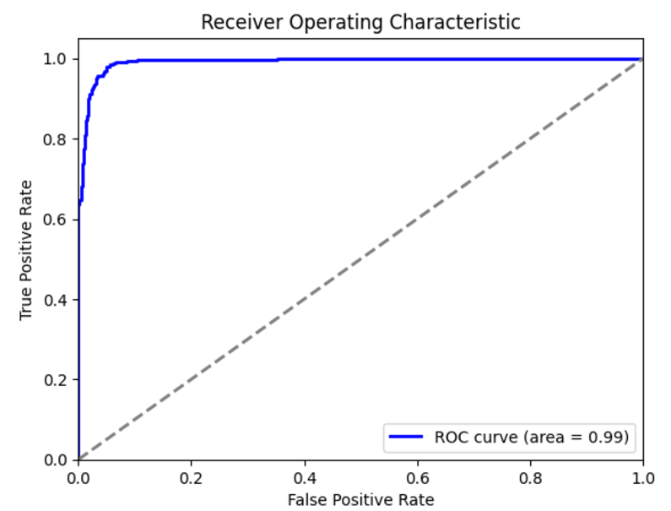

### **5.2.2 Confusion Matrix**

Confusion Matrix provides a clear overview of how well the system is performing by comparing its predictions against the actual states of the drivers. Analyzing this confusion matrix allows developers to pinpoint weaknesses in the detection system, such as a high rate of false negatives, which poses a significant safety risk by failing to identify drowsy drivers. Similarly, frequent false positives could lead to unnecessary alerts that frustrate drivers. By understanding these dynamics, developers can refine the detection algorithms, ultimately enhancing the system's accuracy and contributing to safer driving

**Fig.5** Confusion Matrix

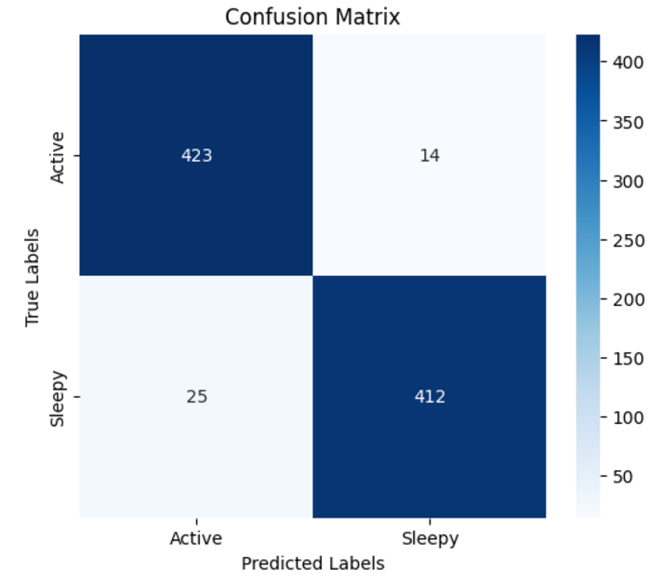

conditions on the road.

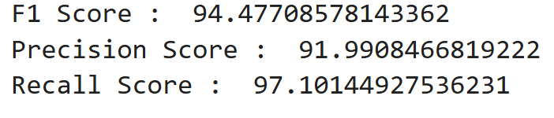

## 5.3 Screenshots

# 

# Conclusion

As we conclude our project on detecting driver drowsiness, we’ve come to appreciate the significant role that technology plays in enhancing road safety. By utilizing advanced algorithms and machine learning techniques, we can create solutions that not only track driver alertness but also provide timely alerts to help prevent potential accidents.

This project has deepened our understanding of how innovative solutions can address real-world challenges, ultimately paving the way for safer driving experiences and reducing the risks associated with drowsy driving.

At the heart of this project is our commitment to addressing a real-world problem—drowsy driving. We hope that our work contributes to reducing the risks associated with this issue and ultimately helps save lives. As we look ahead, we’re inspired by the potential for further research and development in this area, and we believe that our project is just the beginning of what can be achieved in enhancing automotive safety. Together, we can create a safer driving environment for everyone on the road.

While this system effectively alerts drowsy drivers, it is important to note that technology alone cannot eliminate the risks associated with drowsy driving. Drivers must remain aware of their physical limits and avoid relying solely on alerts to stay awake. An alert triggered even one second too late might be insufficient to prevent a crash. Therefore, this system should complement, not replace, responsible driving practices.

# References

1. Wikipedia: [www.wikipedia.org/](http://www.wikipedia.org/)
2. ResearchGate: [www.researchgate.net/](http://www.researchgate.net/)
3. OpenAI: [chat.openai.com](https://chat.openai.com)
4. Kaggle Dataset: [www.kaggle.com/datasets/dheerajperumandla/drowsiness-dataset](http://www.kaggle.com/datasets/dheerajperumandla/drowsiness-dataset)
5. Research Article: [www.mdpi.com/1424-8220/23/14/6459](http://www.mdpi.com/1424-8220/23/14/6459)
6. Drowsy Driving Behaviour Survey: [rosap.ntl.bts.gov/view/dot/1725/dot_1725_DS 1.pdf](https://rosap.ntl.bts.gov/view/dot/1725/dot_1725_DS%201.pdf)

# Contributors

1. SAJAL KORDE  
   Enrolment Number: 221B319  
   Email: [221b319@juetguna.in](mailto:221b319@juetguna.in)

**Personal Email:** [sajal@gmail.com](mailto:sajal@gmail.com)

**Address:**

1. SHRUTI BHARGAVA  
   Enrolment Number: 221B374  
   Email: [221b374@juetguna.in](mailto:221b374@juetguna.in)

**Personal Email:** [shrutibhargava2004@gmail.com](mailto:shrutibhargava2004@gmail.com)

**Address:** Betul, M.P.

1. 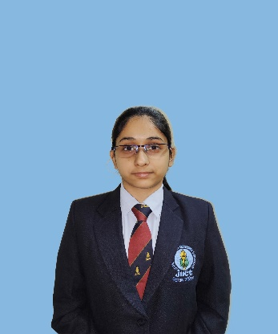SNEHIL SHARMA  
   Enrolment Number: 221B387   
   Email: [221b387@juetguna.in](mailto:221b387@juetguna.in)

**Personal Email:** [ssnehil06@gmail.com](mailto:ssnehil06@gmail.com)

**Address:** Bhilwara, Raj.